Smart Contact Manager

Team ID : SWTID-2026-8752
Team Leader: [NIHARIKAA K & 24csniharikaa.k063@gmail.com]
Team Members:
[MONISHA S & 24csmonisha.s58@gmail.com ]
[NIVEDHA L & 24csnivedha64@gmail.com ]
[SANTHOSHINI S & 24cssanthoshini087@gmail.com ]
[SANDHIYA J & 24cssandhiyaj083@gmail.com ]

1. Project Overview
The Smart Contact Manager is a backend RESTful API built to help users securely store and manage their personal contacts. It features user authentication, protected data access, and full CRUD (Create, Read, Update, Delete) functionality for contact management.
2. Tech Stack
- Runtime Environment: Node.js
- Web Framework: Express.js
- Database: MongoDB (via Mongoose ODM)
- Authentication: JSON Web Tokens (JWT)
- Security: bcryptjs for password hashing
- Validation: express-validator

3. Database Models
User Model
Stores information about the registered users who can manage their own contact lists.
- name: String (Required)
- email: String (Unique, Required)
- password: String (Hashed)
Contact Model
Each contact is linked to a specific user via a userId reference.
- userId: ObjectId (Ref: User)
- name: String (Required)
- email: String (Validated format)
- phone: String
- tags: Array of Strings (e.g., ["Work", "Personal"])
- notes: String

4. API Endpoints
Authentication (Public)
Method | Endpoint | Description
POST | /api/auth/register | Register a new user and receive a JWT.
POST | /api/auth/login | Authenticate user and return a JWT.

Contact Management (Private - Requires Bearer Token)
Method | Endpoint | Description
GET | /api/contacts | Retrieve all contacts for the logged-in user.
POST | /api/contacts | Create a new contact for the logged-in user.
GET | /api/contacts/:id | Get details for a specific contact by ID.
PUT | /api/contacts/:id | Update an existing contact's information.
DELETE | /api/contacts/:id | Remove a contact from the database.
GET | /api/contacts/search | Search contacts by name, email, or tags (Query param: ?q=).

5. Security Features
- Password Hashing: User passwords are never stored in plain text; they are hashed using bcryptjs before being saved to the database.
- JWT Authorization: Private routes are protected by a custom authentication middleware that verifies the user's token before allowing access.
- Data Isolation: The system ensures that users can only view, edit, or delete contacts that belong specifically to their userId.
- Input Validation: Strict validation rules ensure that only correctly formatted data (like valid email addresses and required fields) enters the system.

6. ScreenShots

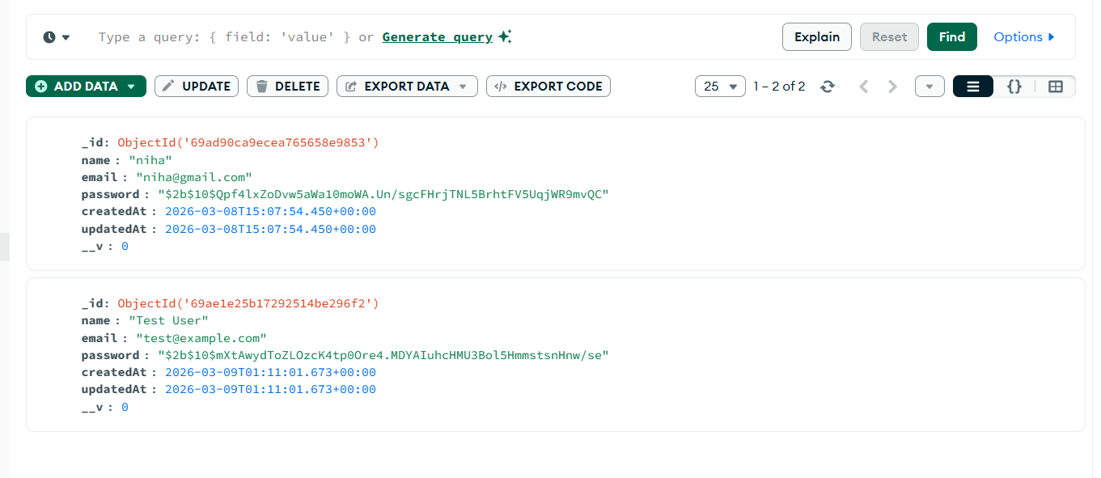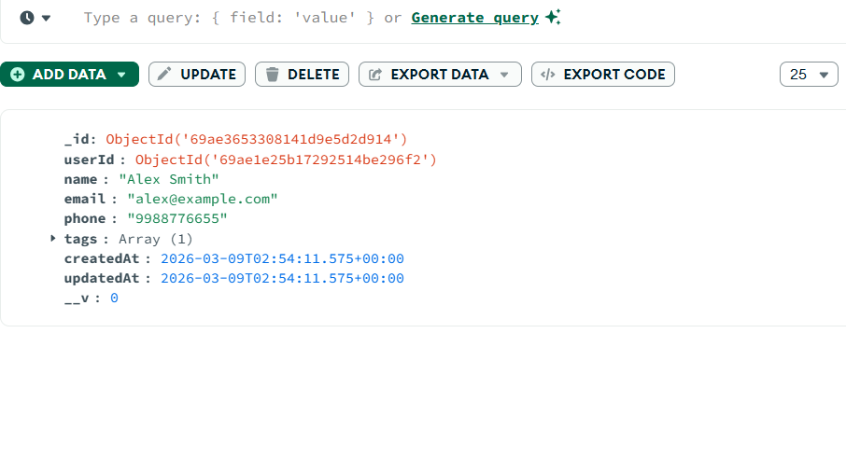

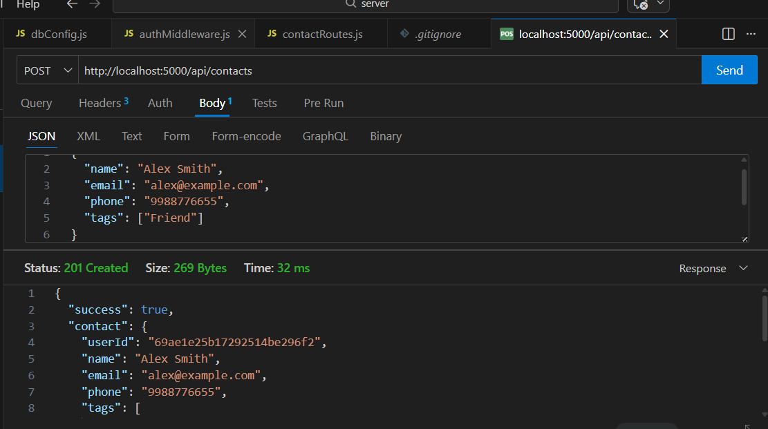
Demo video:

